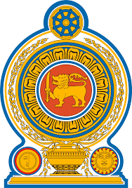
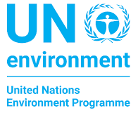
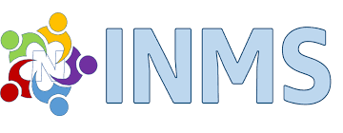

LAUNCH OF
UNITED NATIONS GLOBAL CAMPAIGN ON
SUSTAINABLE NITROGEN MANAGEMENT
Bandaranaike Memorial International Conference Hall. Colombo, Sri Lanka
23 – 24 OCTOBER 2019

LIST OF DOCUMENTS

Working Documents
UNEP-SL/UNGC/ Res.14/1 |  | Provisional agenda
UNEP-SL/UNGC/ Res.L.14/2 |  | Draft Colombo Declaration
UNEP-SL/UNGC/ Res.L.14/3 |  | UNEA-4 Resolution: Sustainable Nitrogen Management
UNEP-SL/UNGC/ Res.L.14/4 |  | Roadmap for Action on Sustainable Nitrogen Management 2020-2022
UNEP-SL/UNGC/ Res.L.14/5 |  | Meeting Report
Information Documents
UNEP-SL/UNGC/ Res.L.14/INF/1 | List of Documents
UNEP-SL/UNGC/ Res.L.14/INF/2 | Logistic Note
UNEP-SL/UNGC/ Res.L.14/INF/3 | Provisional List of Participants
UNEP-SL/UNGC/ Res.L.14/INF/4 | INMS-4 Meeting Report and Summary Report
UNEP-SL/UNGC/ Res.L.14/INF/5 | Publication: ‘Our Nutrients World’
UNEP-SL/UNGC/ Res.L.14/INF/6 | New publication: ‘Nitrogen Grasping the Challenge’

