GOVERNANCE DISCUSSIONS
Guiding principles
Responses to the problem of marine litter and microplastics should be aligned with the 2030 Agenda for Sustainable Development and its Sustainable Development Goals. Political will is essential for effective outcomes. Information and research are critical enablers.
The overall approach should be

- Comprehensive and holistic
- Transparent
- Evidence-based

It should incorporate

- Sea-based and land-based sources
- The circular economy
- The full life-cycle approach

It should target:

- Elimination and prevention
- Immediate as well as sustained, long-term action

It should be supported by and grounded in:

- A science/policy interface
- International cooperation
- Multi-stakeholder engagement
- Realities of differences in local contexts and (technical/financial) capacities

Stakeholders’ roles
- States: role in taking action at the national/local level and engage in international cooperation efforts
- Private sector: role in product design, information transparency, producer responsibility through the full product life cycle, implementation of a circular economy approach, providing finance
- Civil society (NGOs): role in convening stakeholders, fostering community action and citizen science, watch dogs, voicing public opinion, information gathering and dissemination
- International organizations: within their mandates, support coordination and collaboration activities, contribute expertise and linkages with relevant workstreams.
Governance structure:
- Strengthening existing instruments
There is consensus on the need to strengthen existing mechanisms within their mandates and scope. Basel, SAICM, MARPOL, Stockholm, FAO etc. tackle different issues that contribute in addressing MLMP, such as trade, pollution from ships, POPs or transboundary movement and disposal. None of these instruments address the issue in a comprehensive manner. Each existing mechanism has its own governance and State membership structure (e.g. UNEA cannot request action from IMO/MARPOL or from FAO). A gap analysis on compliance/enforcement of existing structures and the possibilities of existing mechanisms to further contribute to the solution would be useful. There is a need for States to coordinate their positions, first at the domestic level (among authorities responsible for different sectors / fisheries, marine affairs, environment, etc) and then in their representation at the international fora relating to MLMP.
- Considering new/enhanced mechanisms for coordination/collaboration (?)
Because of the current fragmented approach, there is also a need to reflect on/design a platform that would address the problem in a holistic manner (as opposed to the fragmentation of addressing the issue through the different existing mechanisms). GPML and/or SAICM, could serve this purpose.
- Considering a global legally binding architecture
Advantages include:
  - More weight
  - Gives countries more confidence to take action if they know that other countries are also taking action (joint efforts, no free-raiders)
  - More effective in supporting coordination at the national level
  - Can provide a set of different measures, such as capacity building and other support mechanisms from developed countries in the implementation of the instrument
Disadvantages include:
  - Duration for the negotiation
  - Resources/cost
Many experts considered that it may be premature to embark on the negotiation of an international legally binding instrument as this may take a long time and immediate action is needed. Many experts also favored the adoption of such an instrument as the only way to address the problem in a holistic manner.
Prevention pillar
- Sound waste management / recycling targets (such as of fishing gear)
- Transparency and information sharing (information on production, consumption and trade, as well as policy options) and research coordination; such as inventories for monitoring (global, regional, national, local or municipal (e.g. for waste management).
- Regulatory measures and guidance on production methods and products/additives
- Measures for standardization, labelling, packaging at the national and international level
Enablers
- A global mechanism for financial and capacity/technical support/cooperation
- Use of policies to promote voluntary commitments and market-based incentives (subsidies and tax reforms)
- Education (consumer education) and awareness raising
- Indigenous and local communities/knowledge

Annex Sweden NGO and Academia and Norway
Potential International Response Options

In consideration of the report Combating Marine Plastic Litter and Microplastics: An Assessment of the Effectiveness of Relevant International, Regional and Subregional Governance Strategies and Approaches – A Summary for Policymakers (UNEP/AHEG/2018/1/INF/3), the following four international response options and governance strategies and approaches were presented and discussed at the first and second meetings of the Ad Hoc Open-Ended Expert Group.

- Response Option – Swedish Experts

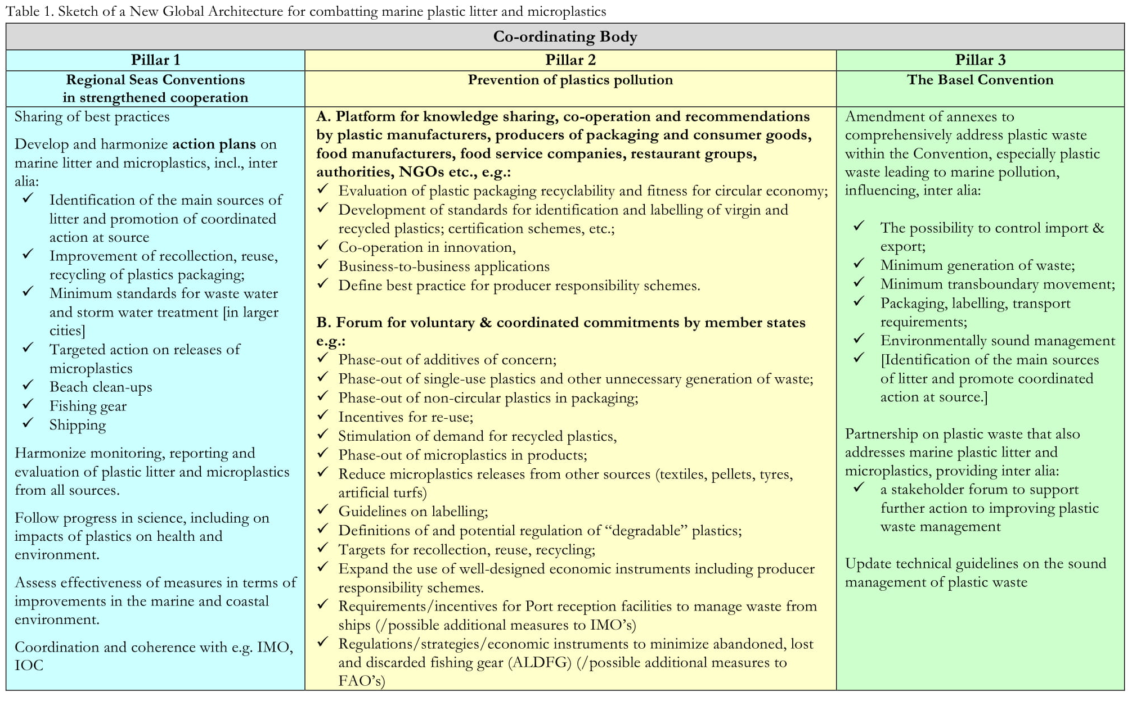
At the Ad-Hoc Open Ended Expert Group, many participants noted the need for enhancing a broader approach, facilitating resource mobilization and minimizing duplication of efforts. Other participants recognized enhanced utilization of existing global and regional mechanisms as important possible support measures, within their respective mandates. Many participants noted that future actions should build on existing global and regional mechanisms that could support the process and seek out avenues where strengthening is needed to enhance their functionality. This proposal was visualized in a sketch, which was made available to participants:

More information is available at:
https://papersmart.unon.org/resolution/uploads/se_experts_14nov18_.pdf
- Response Option – NGO and Academia

Following review of 18 international instruments and 36 regional instruments, the United Nations Environment Programme concluded that “current governance strategies and approaches provide a fragmented approach that does not adequately address marine plastic litter and microplastics.” In order to prevent marine and other plastic pollution, UNEA should mandate or establish a body or authority to coordinate existing conventions and agreements that could be or are taking steps to address aspects of plastic pollution, in full recognition that these are separate bodies with their own mandates and jurisdiction, while also empowering this body or authority to fill the gaps in those existing conventions and agreements and assume new responsibilities for addressing the full lifecycle of plastics, as necessary.

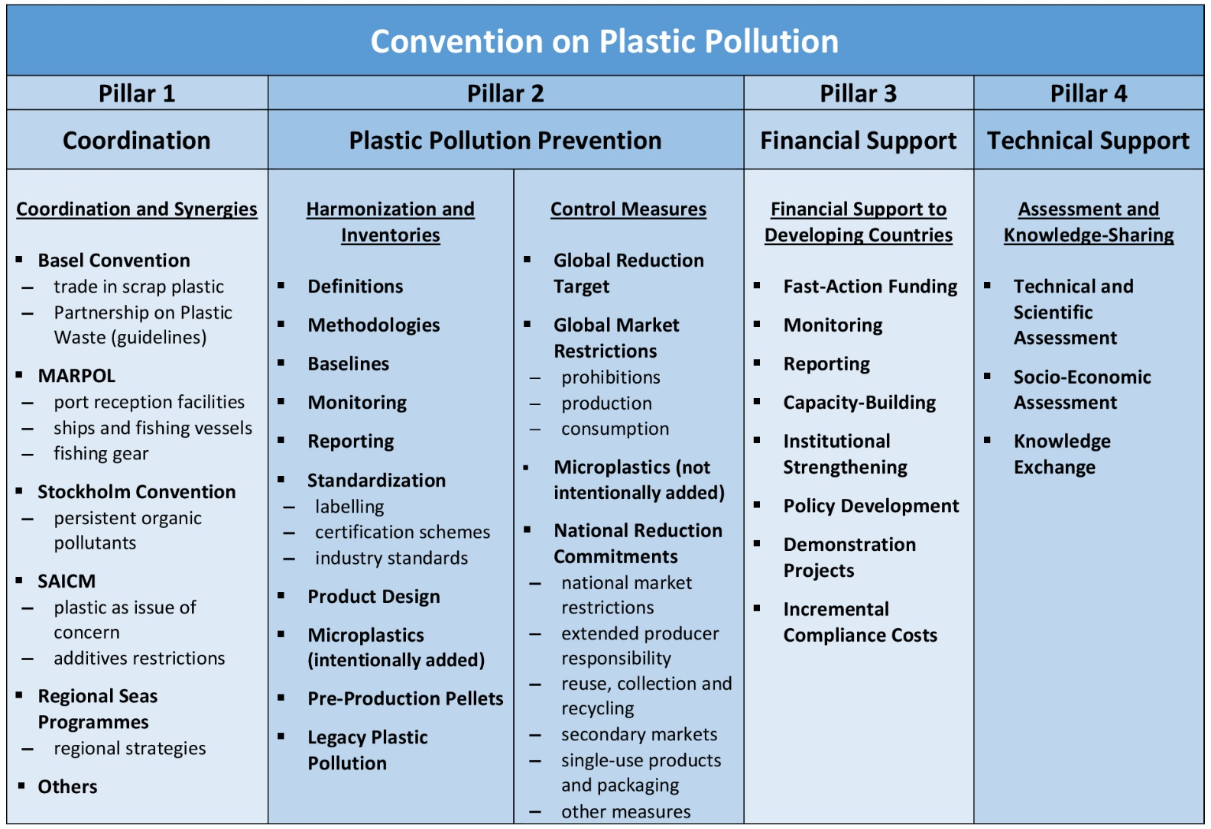
Experts and Member States have identified several areas where activities are needed, which can be broadly bundled into four pillars of action to form the work of a Convention on Plastic Pollution:
More information is available at:
https://papersmart.unon.org/resolution/uploads/thought_starter_-_new_global_convention_on_plastic_pollution_final_november_2018.pdf

- Response Option – Norwegian Proposal for Governance Elements

Building on the agreement pursuant to the resolutions on marine litter and microplastics by UNEA-1, UNEA-2 and UNEA-3, guided by its resolution 3/7 para 1 on the long-term elimination of discharge of litter and microplastics to the oceans and of avoiding detriment to marine ecosystems and the human activities dependent on them from marine litter and microplastics, and the SDG 14.1 goal to, by 2025, prevent and significantly reduce the discharge of litter and microplastics into the oceans.

The UNEA 4 should as an immediate action decide to develop a global governance structure (a legally binding framework or other format) within which governments commit to cooperation for the development of preventive action to combat marine litter and microplastics and to coordinate and prioritize global action, with the following core elements:

- a coordinating mechanism for information, monitoring and data collection and assessments related to marine plastic litter and microplastics at the global level, established as soon as possible as a matter of priority;
- a mechanism for taking stock of global progress at regular intervals, beginning at the latest in 2025, assessing the needs for further action and responding to scientific insights on environmental and health effects from discharges of litter and microplastics into the oceans;
- provisions for enabling, enhancing and supporting preventive action, in particular preventive action upstream covering all sources and releases of marine litter and microplastics;
- sector-specific approaches, as appropriate, including cooperation with and contributions from existing international instruments and/or organizations within their respective mandates;
- regional approaches, as appropriate, including cooperation with and contributions from existing regional instruments and structures within their respective mandates, building on their particular strengths and competences;
- a framework for cooperation, as appropriate, with relevant voluntary initiatives and platforms as well as enhancing contributions from the private sector, civil society, consumers and others;
- capacity-building, financing of support, information exchange, development of technology guidance and other expert advice.

More information is available at: https://papersmart.unon.org/resolution/uploads/noway_submission_governance_elements_for_discussion_at_the_2nd_expert_group_meeting_3011182.pdf

- Response Option – WWF

A new legally binding international agreement on marine plastic pollution will give direction and provide coordination to the global efforts to address this growing menace. It will provide strong support and legitimacy to the efforts of individual Governments for introducing national legislation and policies, set out requirements for national action plans and provide a platform for the establishment of standards, methods and regulations for a coherent and efficient way of dealing with the problem.

Such an agreement will coalesce the efforts of member states for tackling this urgent global problem, and provide non-governmental actors a level playing field and a harmonized legal framework against which to measure performance. This joint global effort should also institutionalise mechanisms to involve developing countries by extending financial and technical implementation support.

UNEA4 should adopt a mandate for starting the negotiations of a legally binding agreement.

Elements that can be included in a new legally binding agreement on marine plastic pollution
Direction | - A clearly formulated vision of eliminating discharge of plastic into the ocean, based on the principle of precaution and in recognition of the devastating impact marine plastic pollution has already shown to have on marine ecosystems, and coastal livelihoods.
Ambition | - An ambitious, shared, timebound and legally binding global reduction target for marine plastic pollution, with particular emphasis on prevention and the need to drastically cut the amount of new plastic waste that ends up in the world’s oceans.  - Clear, measurable and timebound national reduction targets, sufficient, on aggregate, to achieve the global reduction target.
Measures | - An obligation to develop and implement effective national action plans, on prevention, control and removal, sufficiently ambitious to achieve the national reduction targets.  - An agreed measurement, reporting and verification scheme for tracking marine litter and microplastics discharge and the progress made at a national and international level.  - The establishment of an intergovernmental panel of experts that can assess and track the extent of the problem, and collate state-of-the-art knowledge to provide inputs for decision-making and implementation.  - A global funding arrangement to support effective implementation, including for infrastructure development, waste management, innovation into alternative product design and product technology.  - An explicit ban on certain acts considered to defeat the object and purpose of the treaty, including deliberate dumping of plastic waste in river systems and internal waters.  - A commitment to develop common methods, definitions, standards and regulations for an efficient and coordinated global effort to combat marine plastic pollution, including, for instance, specific bans on certain high-risk categories of plastic deemed to be impossible to safely collect and manage.

More information is available at:
https://papersmart.unon.org/resolution/uploads/wwf_position_paper_-_un_expert_group_-_marine_plastic_pollution_-_geneva_-_dec_2018.pdf

